Facility Siting Assessment for PSM
Individual Assignment: Name: __Xinyu Liu___________
Scenario:

Cowboy Oil Company decides to build a new petrochemical facility at an existing complex.

- Process units include:
  - Ethylene
  - Low Pressure Polyethylene
  - Ethylene Glycol
- Other on-site areas with blocks include:
  - Control room
  - Cooling tower
  - Flare
  - Pelletizing and packaging
  - Storage tank farm
  - Maintenance and warehouses
  - Utility area
  - Offices (including the administrative building)
  - Parking lot
- Off-site operations
  - Port facilities for transporting finished products

Proposed Location:
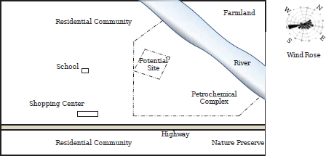
The petrochemical complex is located within an industrial complex that is 20 miles from the nearest town). This facility is located within an industrial complex with industrial neighbors but no communities nearby. A marine facility exists nearby.
The complex has access to the marine facilities that are designed to safely accommodate ships larger than those proposed. The proposed location is one of the last ones remaining in the complex. It has a significant slope and has a dry creek bed that turns into a torrent during heavy rains.
The proposed location is between the existing chemical facility and a fertilizer unit. Additional research located the main electrical power lines along the south property line. There is no separation between the processing facilities – just a fence.
The process safety engineer estimates the risk as being relatively low since the surrounding population is industrial and it is located a sufficient distance from the nearest town. The environmental engineer has identified no concerns with permits or sensitive areas but is concerned with water treatment facilities, given the runoff into the location. The civil/marine engineer is pleased with the marine facilities but concerned with the amount of location preparation required to address the steep slope on the location. Addressing the slope-related issues will add to the cost of the project.
The tank farm and process units (relatively higher risk areas) were separated from the utilities (a medium risk area) and the pelletizing and packaging area (a relatively lower risk area).
- The flare is located on the top tier such that the potential for it being an ignition source is reduced (it is uphill and crosswind from potential release sources).
- The tank farm is located on the lowest tier such that potential spills cannot cascade into other areas of the facility.
- The process units are located in between the flare and the tank farm, helping reduce the risk by separating them from the other areas.
- The on-site utility area is critical for safe shutdowns and was located away from the process units and the tank storage farm. (Note: The location for the main power lines along the lower tier south property line helped dictate the utility area’s location in this example.)
- The cooling tower is designed to serve the process units. The project engineering team recommended locating the cooling tower block adjacent to the process units to help reduce construction costs associated with long lengths of large diameter pipe. By locating the cooling tower on the upper tier away from the process units, potential loss of containment incidents in the process units will have a lower impact on the cooling towers and help keep the overall construction costs lower.
- The offices, including the administration building, were located on the lower tier on the south east corner of the facility’ area. Based on the wind rose diagram for the location, this location is predominately upwind, reducing the potential for personnel exposure if there was a loss of containment.
- The maintenance and warehouse was located in between the tank farm and the offices.
- The central control building was located in between the process units and the offices (a “central” location). Based on additional information from a quantitative risks assessment [e.g., API RP 752], the location of the control room does not incur structural damage or have personnel exposed to toxic concentrations if a loss of containment occurs at the process units.
- One facility access gate was originally located at the lower tier adjacent to the main road. Since there should be more than one access point to the facility, an additional gate was located to provide better accessibility, both for emergency response entry and for personnel egress.
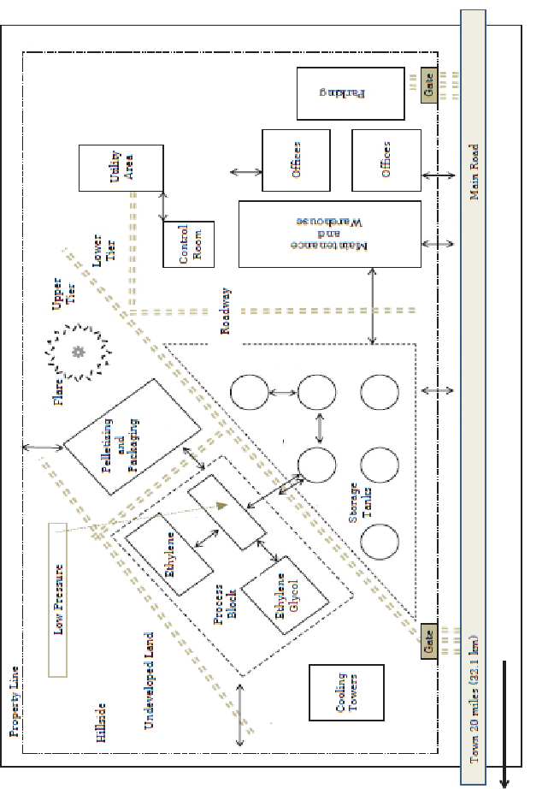
Figure 1 Facility Layout for Structures and Process Unit Blocks
Using CCPS Recommended Distance Table for siting and Layout of Facilities (Appendix B), determine the appropriate separation distances between the process blocks shown in figure 1. Consider fire consequences only.
 | Distance (ft.) – Ground Level or Grade
 | Property Line | Main Road (Public Access) | Access Road (within fence Line | Process Unit Perimeter | Between Storage Tanks | Utility Area
- Property Line
- Main Road (Public Access)
- Access Road (within fence Line
- Process Unit Perimeter | 200 ft  Table B.1-E B.1-2 |  | 50 ft  Table B.5-E  B.5-1 | 100 ft  Table B.1-E  B.1-1
- Pelletizing and Packaging
- Storage Tank Perimeter  (ATM Storage, Floating roof, > 10,000 gal, | 100 ft  Table B.2-E  B.2-1 | 100 ft  Table B.2-E  B.2-2 | 100ft  Table  B.2.E  B.2.2 | 200 ft  Table B.2-E  B.2-4
- Between Storage Tanks Perimeter  (ATM Storage, Floating Roof, > 10,000 gal, |  |  |  |  | 1xD ft  Table B.3-E  B.3-3
- Control Room |  |  |  |  |  | 100 ft  Table B.4-E  B.4-7
- Maintenance And Warehouse | NM  Table B.4-E  B.4-1 |  |  | 200 ft  Table B.4-E  B.4-1 |  | 100 ft  Table B.4-E  B.4-1
- Offices | NM  Table B.4-E  B.4-1 |  |  | 200 ft  Table B.4-E  B.4-1
- Flare |  |  |  | 100 ft  Table B.7-E  B.7-2 |  | 500 ft  Table B.7-E  B.7-1

Layout of the Ethylene Unit’s Process Unit
Hydrocarbon feedstock streams supplying the ethylene process can include: ethane, propane, or butane. These feedstock streams pass through the tubes of a cracking furnace heated by burning a fuel gas in the furnace. Steam injection is used in the tubes to control yields and to help prevent coke formation.

Subjecting the feedstock to high temperatures results in a partial conversion of the feedstock to ethylene and hydrogen. After the cracking furnace, the process stream is compressed to a higher pressure using cracked gas compressors and is then sent to a cryogenic unit for separation and purification. The major products of this process are ethylene and propylene.

The major pieces of equipment for the cracking furnace unit are listed below:
- a superheater
- five ethylene cracking furnaces (A-E)
- two cracked gas compressors
- pumps handling hydrocarbons at high temperatures and pressures
- boiler feedwater pumps
- quench process equipment, including heat exchangers
- a unit pipe-way, and
- a number of firewater spray systems

Process Parameters
- The superheater and five ethylene cracking furnaces (potential ignition sources) are located together on the upwind side of the process unit and are separated from the pipe-way.
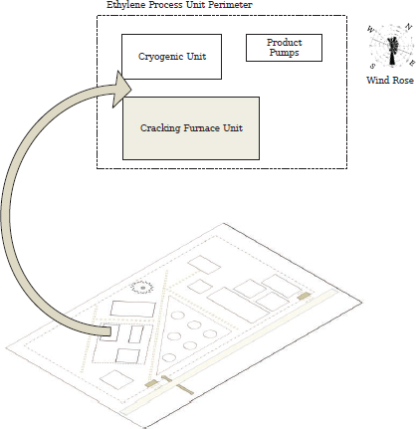
- Since the two cracked gas compressors are potential release points for flammable and explosive material, they are located on the opposite, downwind side of the unit from the furnaces, maximizing their separation distance and placing them downwind of the potential ignition sources.
- The pumps are grouped by their risk level with the pumps handling hydrocarbons at high temperatures and pressures in one group, and the boiler feedwater pumps in another. Both groups of pumps are located in a row along an access way for accessibility during maintenance for pump lifts, if needed.
- The vessels in the quench process are also grouped together and located downwind of the furnaces, with their heat exchangers laid out with room for pulling tube bundles during maintenance.
- The pump row for the pumps handling flammables is located adjacent to the unit pipe-way. This pipe-way is fireproofed and the pumps are protected with a firewater spray system, reducing the consequences and isolating a pump fire. Air-cooled heat exchangers in the quench area are not located above these pumps.
- All the firewater spray system actuation stations are located in a bank at the edge of the unit in the direction of the control room. This places the actuation points outside of the fire hazard areas, makes them easily accessible, and places them on a likely path of travel in case of an emergency.
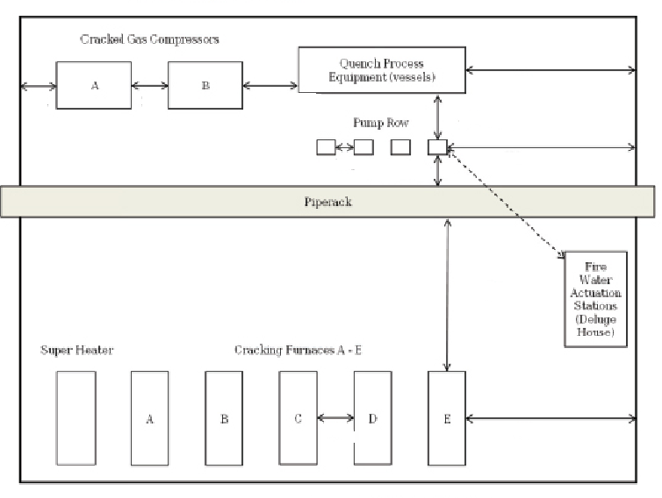
Figure 2 Layout of the Equipment in the Cracking Furnace Unit

Using CCPS Recommended Distance Table for siting and Layout of Facilities (Appendix B), determine the appropriate separation distances between the cracking furnace unit process block shown in figure 2. Consider fire consequences only.
 | Distance (ft) – Ground Level or Grade
 | Cracked Gas Compressors | Quench Process Equipment (Vessels) | Pumps | Pipe Rack
 | 1 | 2 | 3 | 4
- Cracked Gas Compressors
- Quench Process Equipment (Vessels) | 100 ft  Table B.1-E  B.1-16
- Pumps |  | 15ft  Table B.1-E  B.1-17
- Pipe Rack |  |  | 50 ft  Table B.1-E  B.1-21
- Cracking Furnaces |  |  |  | 50 ft  Table B.1-E  B.1-21

